Department: Information technology Engineering

Name: Mut Chhay

Class M2

Course: WTC

Task 1.

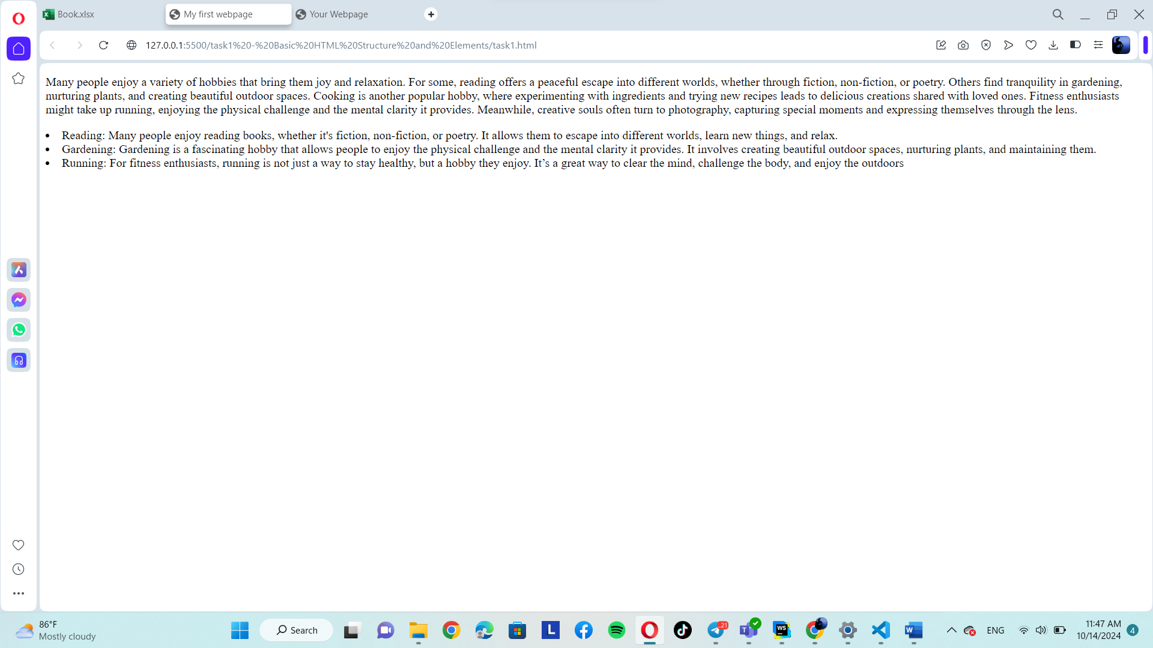

Task 2

